P4.1 Matter Pre-Unit Quiz

- In which state(s) of matter are particles free to move? [1]
Tick ( ) one box.
- Solids and liquids | 
- Liquids and gases
- Gases only

- In which state of matter do particles have the most energy? [1]
Tick ( ) one box.
- Solid
- Liquid
- Gas

- Which state(s) of matter can be compressed? [1]
Tick ( ) one box.
- Gases only
- Liquids and gases
- Solids, liquids and gases

- Water is boiled in a kettle. Which statement correctly describes what has happened to the particles? [1]
Tick ( ) one box.
- Water particles (liquid) have turned into steam particles (gas)
- Particles have more energy so they are able to move more quickly in random directions
- Water particles have chemically reacted with oxygen to form steam

- A student filled and sealed two syringes, one with a gas and the other with a liquid, as shown in figure 1.

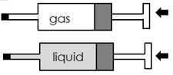
Figure 1

Figure 2 shows the syringes after the plungers were pushed.

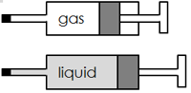
Figure 2

Choose the statement that explains why the gas was compressed more than the liquid. [1]
Tick ( ) one box.
- The particles in gases are more spread out than the particles in liquids
- The particles in gases have less mass than the particles in liquids.
- The particles in gases are softer than the particles in liquids

- Which best explains why oil floats on water? [1]
Tick ( ) one box.
- Oil is lighter than water
- Oil is less dense than water
- Oil is more dense than water

- Which state of matter has the greatest density? [1]
Tick ( ) one box.
- Solid
- Liquid
- Gas

- Choose the correct definition of internal energy. [1]
Tick ( ) one box.
- The total kinetic energy of all the particles in a system
- The total kinetic and potential energy of all the particles in a system
- The total energy transferred when a substance changes state

- A student has plotted a heating curve of water.
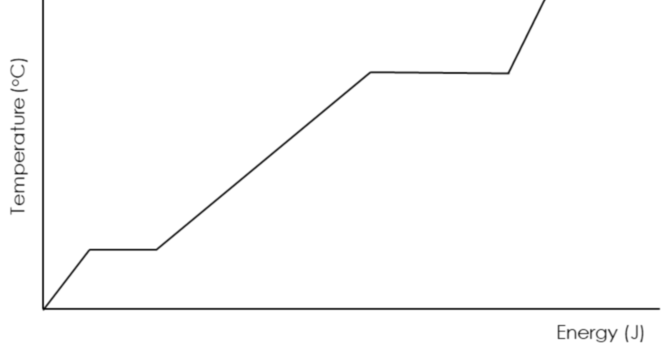

B

A

Choose the statement that is correct for line AB.
Tick ( ) one box.
- Kinetic energy and potential energy are increasing
- Kinetic energy and internal energy are increasing
- Potential energy and internal energy are increasing

- An object has a mass of 10 g and a volume of 2 cm³.

Choose the density of this object. [1]
Tick ( ) one box.
- 0.2 g/cm³
- 5 g/cm³
- 20 g/cm³

